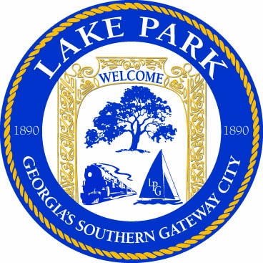

120 North Essa Street, Lake Park, Georgia 31636
City Hall 229-559-7470
Fax 229-559-7499

Information about Moving Structures in city limits

Mover MUST obtain moving permit from its present location from the Lowndes County/Valdosta building department.

Property owner must obtain zoning letter/building application from the City of Lake Park in order to obtain actual building permit and septic permit from Lowndes County.

Building permit must be obtained before structure is taken off moving rails, footers/support along with termite inspection will be done by Lowndes County permitting office at that time.

