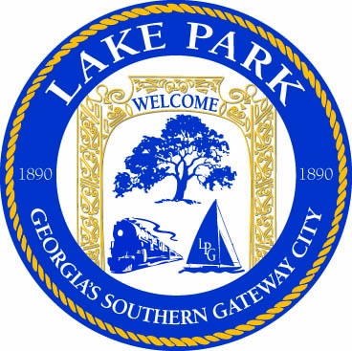

120 North Essa Street, Lake Park, Georgia 31636
City Hall 229-559-7470
Fax 229-559-7499

Information about Annexation, De-annexation, Rezoning, Subdivisions and Special Exceptions

Fees to apply for a Variance, Extension of Nonconforming Residential Uses, and Continue of Nonconforming Use = $300 with an addition $6.91 (or current cost) cost per certified letter required to notify surrounding property owners.

All completed applications must be submitted to city hall. City Hall will submit the application to the Greater Lowndes Planning Commission for recommendation, which holds their meeting on the last Monday of the month. (all agenda items must be submitted to them no less than the week prior)

City Council will hold a Public Hearing the first Tuesday of the following month that the Planning Commission has heard the case.

